A close up of a logo

Description generated with very high confidence

Author(s): Christopher Busch

Date: 1/22/2018

|  |  |  |  |
| --- | --- | --- | --- |
|  | A close up of a logo  Description generated with very high confidence | + | A picture containing object  Description generated with high confidence |
| LaaS: Partner Reporting Prototype  MySQL and Power BI | | | |

Contents

MySQL Installation & Configuration 2

Your MySQL Instance 3

New Reporting through Power BI Desktop 6

Utilizing The Power BI Template File With Your MySQL Instance 11

Power BI Report Model Template Sample 14

Power BI Reporting Sample Template 15

Additional Documentation and Learning: 17

Appendix A 17

## MySQL Installation & Configuration

**Installation:**

 Download MySQL Installer From [https://dev.MySQL .com/downloads/installer/](https://dev.mysql.com/downloads/installer/)

Get the latest version.

Once installed, open MySQL Installer

Add below components (Click on Add Option on the wizard):

**MySQL Server** -- This the Server Instance

**MySQL Workbench** -- Query editor to query MySQL tables

**Connector/NET --** Connector to connect programmatically to mySQL Instance

**Configure MySQL:**

After installing above components, follow below steps to configure MySQL Instance. Note. We could configure MySQL while installing MySQL Server as well.

On MySQL Installer page, click on **Configure** link shown under **Actions** for MySQL Server

On configuration wizard,

**Type & Networking Page**-> Select **Server Machine** as Config Type. Enable TCP/IP port 3306 (default). Click Next

**Accounts and Roles page ->** Create Root Pwd. MySQL creates root user with this pwd. On this page, create other users as needed. Click Next.

**Windows Service Page** -> Enter custom name for Service (if needed). MySQL will be configured with this name. Click Next

**Plugins and Extensions Page ->** Enable X Protocol and Document store, If MySQL is used as Document Store. Check Open firewall port for Network access. Click Next

**Apply Configuration Pahe ->** Click on Execute to complete configuration.

**Restoring Database backup:**

**For more details on Open edX Azure STAMP deployment backup mysql, please see Appendix A**

**Restore will depend on how the backup was performed, MySQL Database dump can be restored using MySQL Backup.exe or MySQL Dump.exe**

**Assuming backup was taken using MySQL Dump.exe:**

To Restore MySQL database backup, from command prompt navigate to MySQL Server 5.7\bin (generally @ C:\Program Files\MySQL \MySQL Server 5.7\bin)

Run below command to restore the DB.

**MySQL dump.exe -u** root **-p**<root accnt pwd> **--**<database name to restore> **>** <Backup File name>

If the backup was a Server Dump (not individual DB dump)

**MySQL dump.exe -u** root **-p**<root accnt pwd> **sys >** <Backup File name>

More details on backup & restore can be found @ [https://dev.MySQL .com/doc/MySQL -enterprise-backup/4.1/en/](https://dev.mysql.com/doc/mysql-enterprise-backup/4.1/en/)

## Your MySQL Instance

|  |  |
| --- | --- |
| Steps |  |
| 1. Download MySQL Workbench | <https://dev.mysql.com/downloads/workbench/> |
| 1. Connect to Database |  |
| 1. Enter Credentials |  |
| 1. MySQL Workbench Environment |  |
| 1. Tables used in report template: | * edxapp.auth_userprofile * edxapp.course_overviews_courseoverview * edxapp.grades_persistentcoursegrade * edxapp.student_courseenrollment |
|  | |

## New Reporting through Power BI Desktop

Something

|  |  |
| --- | --- |
| Steps |  |
| 1. Download Power BI Desktop. | <https://powerbi.microsoft.com/en-us/desktop/> |
| 1. Connect To MySQL Database by clicking on Get data. |  |
| 1. From the Get Data window, choose MySQL & click Connect. |  |
| 1. Add Server & Database name, click OK. |  |
| 1. Choose Database & enter User name and password. Click Connect. |  |
| 1. Under the Navigator window, check the appropriate tables.  * edxapp.auth_userprofile * edxapp.course_overviews_courseoverview * edxapp.grades_persistentcoursegrade * edxapp.student_courseenrollment |  |
| 1. In the Modeling ribbon, choose New Table. |  |
| 1. Create Calendar Table Inside Model by adding new measures in the formula bar: 2. Calendar = CALENDAR("1/1/2016","12/31/2018") 3. WeekDay = WEEKDAY('Calendar'[Date].[Date]) 4. WorkDay = IF(OR('Calendar'[WeekDay]=1,'Calendar'[WeekDay]=7),0,1) 5. Day = UPPER(LEFT(FORMAT('Calendar'[Date].[Date],"dddd"),3)) 6. Month = 'Calendar'[Date].[MonthNo] 7. MonthName = UPPER(LEFT('Calendar'[Date].[Month],3)) 8. Year = YEAR([Date].[Date]) |  |
|  | |

|  |  |
| --- | --- |
| Additional Columns (Measures) | DAX Formulas |
| **Active Courses** | = CALCULATE (  DISTINCTCOUNT ( 'edxapp course_overviews_courseoverview'[id] ),  'edxapp course_overviews_courseoverview'[has_any_active_web_certificate] = TRUE()  ) |
| **Total Courses** | = DISTINCTCOUNT ( 'edxapp course_overviews_courseoverview'[id] ) |
| **% Change Course Completions** | = DIVIDE([Course Completions],[Course Completions Prior],Blank())-1 |
| **Course Completions** | = CALCULATE (  COUNT ( 'edxapp grades_persistentcoursegrade'[id] ),  FILTER (  'edxapp grades_persistentcoursegrade',  'edxapp grades_persistentcoursegrade'[letter_grade] = "Pass"  ),  USERELATIONSHIP ( 'Calendar'[Date], 'edxapp grades_persistentcoursegrade'[passed_timestamp] )  ) |
| **Course Completions Prior** | = CALCULATE([Course Completions],PREVIOUSMONTH('Calendar'[Date])) |
| **% Change Distinct User Enrollments** | = DIVIDE([Distinct User Enrollments],[Distinct User Enrollments Prior],Blank())-1 |
| **% Change User Enrollments** | = DIVIDE([User Enrollments],[User Enrollments Prior],Blank())-1 |
| **Distinct User Enrollments** | =  DISTINCTCOUNT('edxapp student_courseenrollment'[user_id]) |
| **Distinct User Enrollments Prior** | = CALCULATE([Distinct User Enrollments],PREVIOUSMONTH('Calendar'[Date])) |
| **Enrollment Date** | = DATE ( YEAR ( [created] + TIME ( 8, 0, 0 ) ), MONTH ( [created] + TIME ( 8, 0, 0 ) ), DAY ( [created] + TIME ( 8, 0, 0 ) ) ) |
| **User Enrollments** | = COUNT('edxapp student_courseenrollment'[user_id]) |
| **User Enrollments Prior** | = CALCULATE([User Enrollments],PREVIOUSMONTH('Calendar'[Date])) |
|  |  |

## Utilizing The Power BI Template File With Your MySQL Instance

|  |  |
| --- | --- |
| Steps | |
| 1. Open **.pbix** file in Power BI Desktop. |  |
| 1. In the **Home** Ribbon, choose **Edit Queries** > **Data Source Settings** |  |
| 1. Under **Data Source Settings**, choose **Change Source**… below the sources window. |  |
| 1. Change Server & Database name, click **OK** |  |
| 1. Choose Database & enter User name and password.   Click **Connect**. |  |
| 1. **Apply Changes** from the top banner |  |
|  | |

## Power BI Report Model Template Sample

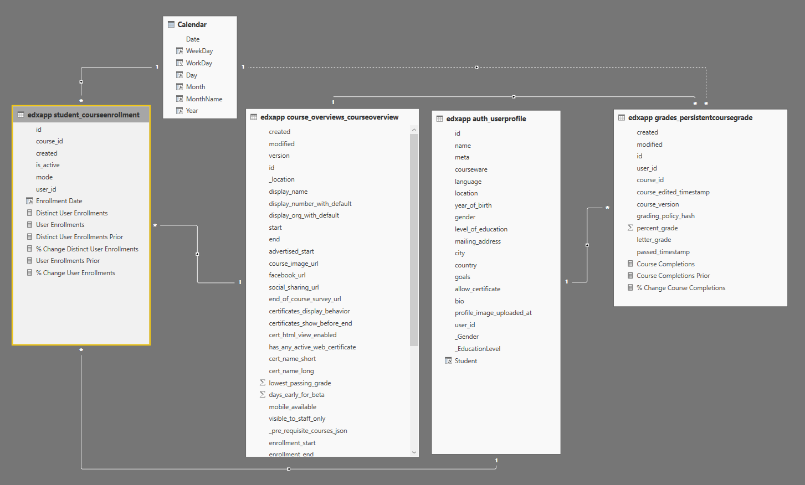

## Power BI Reporting Sample Template

The sample Power BI template provides a starting point on which a partner can establish reporting tailored to their own organizational goals.

|  |  |
| --- | --- |
| Overview Tab | |
|  | 1. Page Filter Section 2. Trended User Count 3. Period Over Period Comparison Of Enrollment Statistics 4. Aggregated Geography View 5. Trended Variance of Monthly Performance |

|  |  |
| --- | --- |
| Course Tab | |
|  | 1. Page Filter Section 2. Cumulative Metric Tiles 3. Trended Enrollments vs Completions 4. Course Completion % By Gender 5. Course Completion % By Education Level 6. Student Detail Data Table for Sorting / Export |

## Additional Documentation and Learning:

Power BI Resources: <https://powerbi.microsoft.com/en-us/learning/>

MySQL Resources: <https://www.mysql.com/>

## Appendix A

If you used Ficus STAMP deployment script provided by Microsoft, on your Azure portal you will find a storage account (look for it in the resource group you used for deployment) with Azure Storage Blobs for backup mySQL database where learner data is stored. For example, if you used the resource group name to be testrsc1, the storage account would be with name testrsc1securesa. 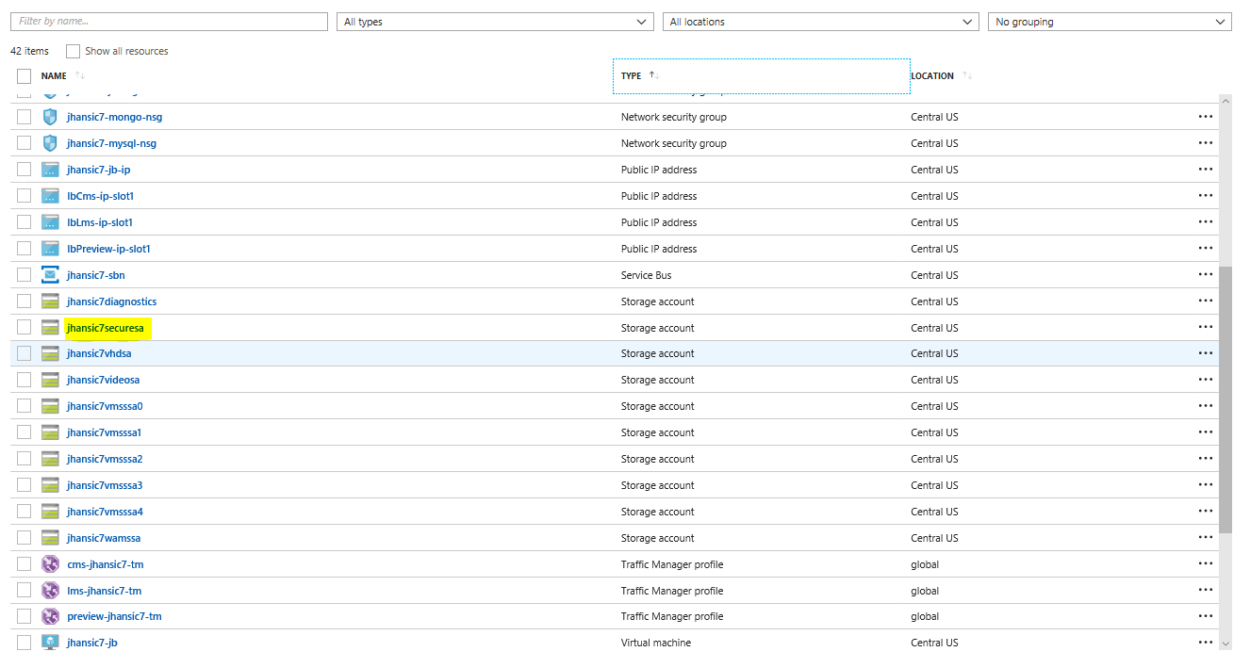Select the storage account mentioned above, you will see a section called Blobs.

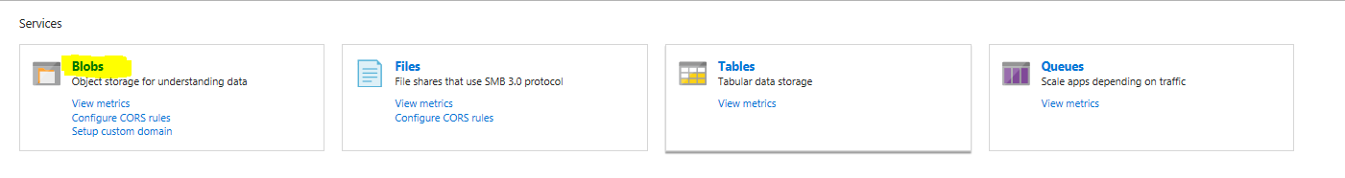Select Blobs service. This will give you access to the contianers where backups are stored for mySQL and mongoDB.

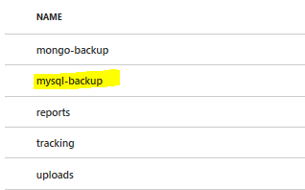

Once you select mysql-backup container, you will see all the time-stamped backup mySQL files.

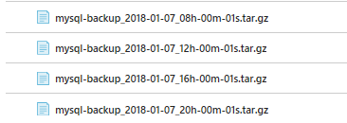

The configurations (backup cadence, user name and password) are all part of your deployment parameters (provided in parameters.json file). These would be the backups you can restore from for generating the reports.